Anatomical snuffbox
- A term given to the triangular depression formed on the posterolateral side of the wrist and first metacarpal
- Historically, ground tobacco (snuff) was placed in this depression before being inhaled into the nose

Boundaries
- Radial border (Lateral): tendons of the abductor pollicis longus and extensor pollicis brevis
- Ulnar (Medial) border: tendon of the extensor pollicis longus
- Floor: formed by the scaphoid and trapezium

Structures related
- Radial artery
- Superficial branch of the radial nerve
- Origin of the cephalic vein from the dorsal venous arch of the hand

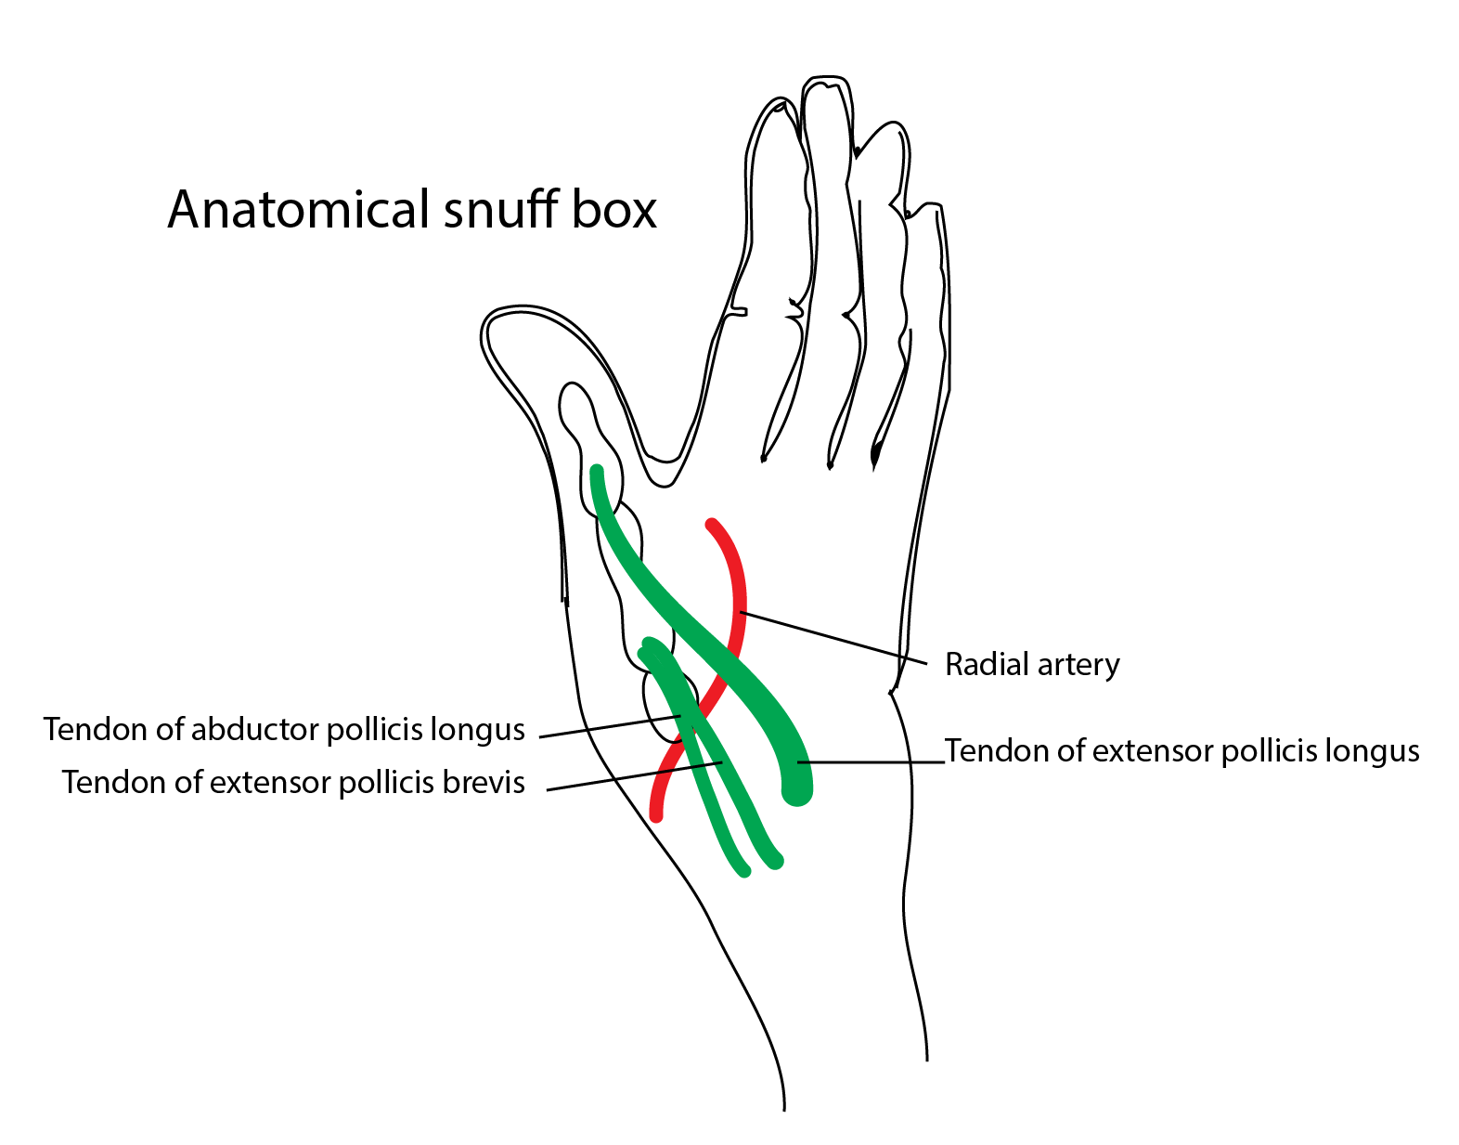

Applied aspects
When the hand is in ulnar deviation, the scaphoid becomes palpable within the snuffbox.
This position enables the physician to palpate the bone to assess for a fracture.
The pulse of the radial artery can also be felt in the snuffbox
[CLINICAL]Pain in anatomical snuff box = possible fracture of radial styloid process.

